Paint by Number Geometric Shapes

This lesson came from the website Mini Matisse
Prep: copy a grid onto finger paint paper or students could do this if you make each student a wide template on cardstock for tracing a grid. Divide the width and length into equal squares of 2-2 ½ inches, large enough to finger paint in.
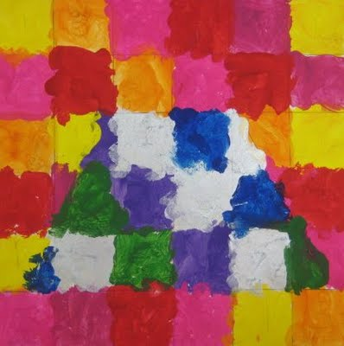
1st grade students worked on their math skills as they learned how to create their own paint by number. I was excited to introduce this younger generation to something I loved to do as a kid, PAINT BY NUMBER!

The visual art objective for this lesson was to identify and create six new geometric shapes. Last year in Kindergarten student learned what a circle, triangle, oval, square and rectangle was. These shapes were reviewed first. In first grade they studied a pentagon, octagon, rhombus, trapezoid, parallelogram and hexagon.
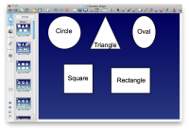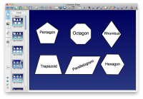
The math part of this lesson was to demonstrate the knowledge of even and odd numbers. Other skills that were used in this project was how to create a grid and use a ruler to do so.
The kids drew a grid on their paper and then then a large shape. There were instructed that on the inside of the shape they were to put a even number. On the outside of the shape, they had to place odd numbers in each grid space.
The next day the kids were asked to use the correct colors for each number. They loved the challenge.
